# Topic: Dimension Reduction With PCA

**Instructions:**

Please share your answers filled in-line in the word document. Submit code separately wherever applicable.

Please ensure you update all the details:

**Name: _____________ Batch ID:** ___________

**Topic: Principal Component Analysis**

**Hints:**

1. **Business Problem**
   1. **What is the business objective?**
   2. **Are there any constraints?**
2. **Work on each feature of the dataset to create a data dictionary as displayed in the below image:**

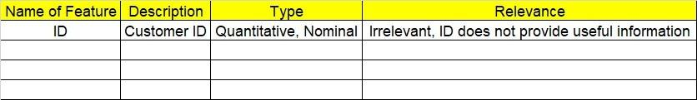

**2.1 Make a table as shown above and provide information about the features such as its data type and its relevance to the model building. And if not relevant, provide reasons and a description of the feature.**

1. **Data Pre-processing**

**3.1 Data Cleaning, Feature Engineering, etc.**

1. **Exploratory Data Analysis (EDA):**
   1. **Summary.**
   2. **Univariate analysis.**
   3. **Bivariate analysis.**
2. **Model Building**
   1. **Build the model on the scaled data (try multiple options).**

**5.2 Perform PCA analysis and get the maximum variance between components.**

**5.3 Perform clustering before and after applying PCA to cross the number of clusters formed.**

**5.4 Briefly explain the model output in the documentation.**

1. **Write about the benefits/impact of the solution - in what way does the business (client) benefit from the solution provided?**

**Problem Statement: -**

Perform hierarchical and K-means clustering on the dataset. After that, perform PCA on the dataset and extract the first 3 principal components and make a new dataset with these 3 principal components as the columns. Now, on this new dataset, perform hierarchical and K-means clustering. Compare the results of clustering on the original dataset and clustering on the principal components dataset (use the scree plot technique to obtain the optimum number of clusters in K-means clustering and check if you’re getting similar results with and without PCA).

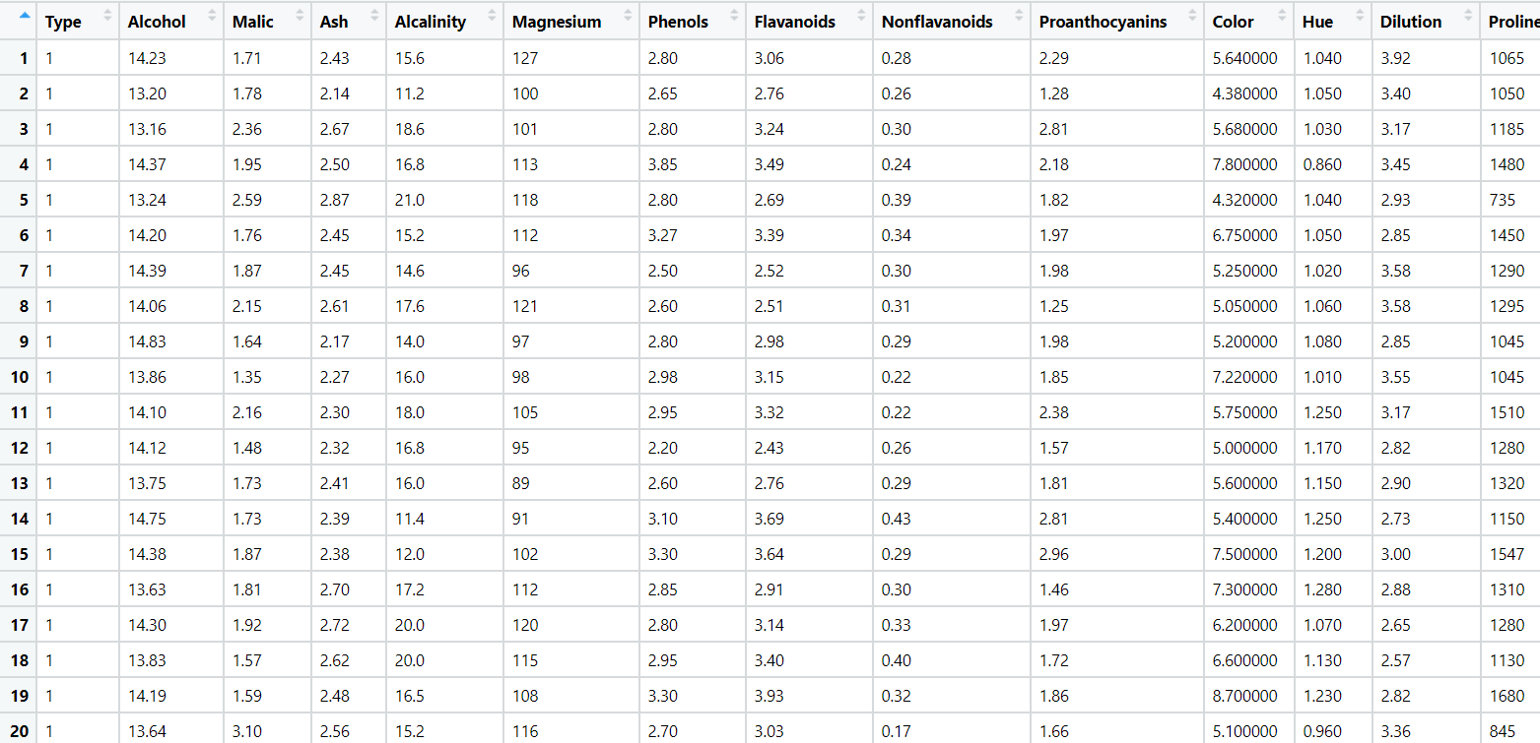

**Problem Statement: -**

A pharmaceuticals manufacturing company is conducting a study on a new medicine to treat heart diseases. The company has gathered data from its secondary sources and would like you to provide high level analytical insights on the data. Its aim is to segregate patients depending on their age group and other factors given in the data. Perform PCA and clustering algorithms on the dataset and check if the clusters formed before and after PCA are the same and provide a brief report on your model. You can also explore more ways to improve your model.

Note: This is just a snapshot of the data. The datasets can be downloaded from AiSpry LMS in the Hands-On Material section.